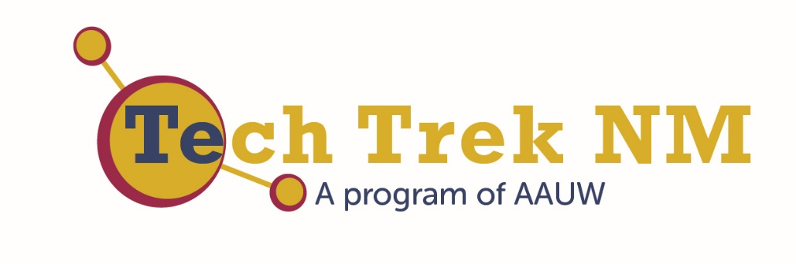

Professional Women’s Dinner

Wednesday, July 15, 2015

New Mexico Highlands University

Las Vegas, New Mexico

Our mission: Advancing equity for women and girls through advocacy, education, philanthropy, and research.

The American Association of University Women (AAUW) is the nation’s leading voice promoting equity and education for women and girls. Since our founding in 1881, AAUW members have examined and taken positions on the fundamental issues of the day — educational, social, economic, and political.

Tech Trek 2015 Steering Committee
Director | Elizabeth Ratzlaff | Las Vegas
Assistant Director | Karyl Lyne | Las Vegas
Fundraising Coordinator | Mary Rita Chapman | Las Cruces
Family & Student Involvement Coordinator | Cheri Burch | Albuquerque
Social Media Coordinator | Helena Whyte | Los Alamos
Marketing Coordinator | Jan Bandrofchak | Albuquerque
Volunteer Coordinator | Mary Schipper | Las Vegas

To learn more about AAUW’s groundbreaking studies: Solving the Equation: The Variables for Women’s Success in Engineering and Computing and Why So Few? Women in Science, Technology, Engineering, and Mathematics?, visit the AAUW website: www.aauw.org/learn/research/whysofew.cfm
http://www.aauw.org/research/solving-the-equation/

You can reach us at: http://aauw-nm.aauw.net/
Facebook: https://www.facebook.com/aauw.new.mexico
Twitter: https://twitter.com/aauwnm
Professional Women
Amanda Aragon  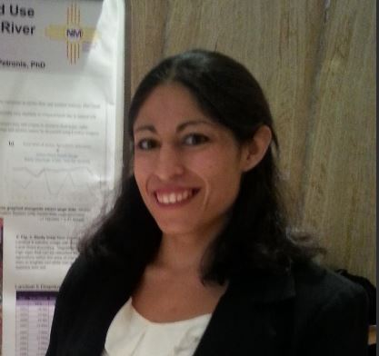 | Amanda is from the rural town of Peralta, New Mexico and grew up with a strong family foundation and a father who encouraged her. She studied Geology at New Mexico Tech and received her bachelors in University Studies from New Mexico Highlands University in 2009. She is currently seeking a dual master’s degree in Environmental Science and Anthropology with graduate certificates in Geographic Information Systems (GIS) and Cultural Resource Management (CRM). She is working on a Remote Sensing thesis project using satellite imagery to evaluate trends in agriculture along the Pecos River. Amanda is the Chair of the national Student Advisory Council of the American Society for Photogrammetry and Remote Sensing and President of the NMHU Geospatial Club.  When not doing science, she enjoys spending time with her dogs, bike riding, and traveling.
Phyllis Baca  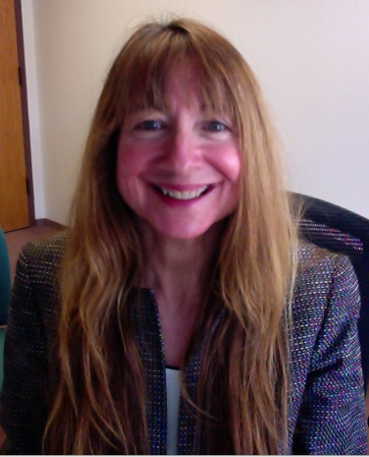 | Phyllis Baca is an engineering faculty member who also serves as the Director of STEM Initiatives at Santa Fe Community College. She aligns herself with the American Competitiveness Initiative in that her over-arching goal is to double the number of underrepresented minorities and women graduating in STEM programs. Her chemical engineering background coupled with her alternative teaching licensure allows for a unique perspective to serve NM students.  Eight years ago, she began her career in academia and focused on revitalizing the Engineering and Engineering Technologies degree programs through clear career pathways tied to State and National career clusters. Her passion is to present STEM opportunities to low-income, Hispanic students through high school dual-enrollment and eventually retain them as first generation college students.  Many of these initiatives have been funded through two and half million dollars in grant funding that she has obtained.
Helen Bolen  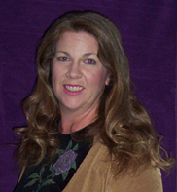 | Helen Bolen has a Master's degree in Education with a minor in Geology and a bachelor's degree in Biology. She has worked in seven different research labs, extracting and sequencing the DNA of such things as cats, rats, rabbits, Loblolly Pines, fungus, and bacteria. She has also served as a clinical research coordinator, assisting with blind and double blind drug trials of 2 different cancer pharmaceuticals.  After teaching science to every grade level, kinder through 12th grade, she is currently semi-retired and is working as the Educational Director for Manzano Christian School. Her hobbies include fossil and rock collecting and occasionally gold panning. This is her second Tech Trek.
Sara Brown  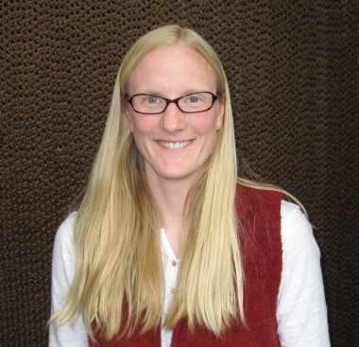 | Sara Brown is an Assistant Professor of Forestry at New Mexico Highlands University. She teaches wildfire science and ecology courses, and enjoys working on research problems in the field with her students. She earned her Ph.D. in ecology from the University of Wyoming, her MS in environmental science and regional planning from Washington State University and her BS in environmental science from Willamette University.  From 1996-2007, she worked for a variety of federal land management agencies in fire suppression and fire management. She worked on a type-2 fire crew, a helicopter crew, a hotshot crew and as a smokejumper. During that time, she became aware of the importance of integrating scientific research into land management decisions.
Erica Guaba  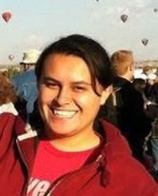 | Erika Guaba is a native of Bogota, Colombia who has lived in New Mexico since 2007. She received a BS in chemistry from New Mexico Highlands University.  Currently she is a chemist at the Scientific Laboratory Division in the Toxicology Bureau for the State of New Mexico. She is a part of performs analytical tests on blood samples; testing for alcohol and an 18-panel drug screen on samples from all over the state.
Lina Germann  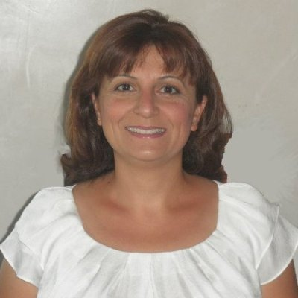 | Lina Germann is a science educator, consultant and active community member. Her passion is advocacy for women and girls, focusing on increasing the number of women and girls pursuing STEM careers.  Lina works as a facilitator in Project GUTS (Growing Up Thinking Scientifically) - a program developed by the Santa Fe Institute - developing curriculum and providing professional development to New Mexico teachers. She also spearheads STEM events in Santa Fe such as Expanding Your Horizons Conference and Careers & Curiosity in Math and Science fairs.  Lina is a member of AAUW-SF, Santa Fe Alliance for Science, SFPS Adelante program, First Tee of Santa Fe, and NM Network of Women in Science and Engineering.  With a Ph.D. in Physical Chemistry from Boston College, and a MBA degree from UNM, Lina has taught chemistry at the community college and high school level.
Erin Grassie  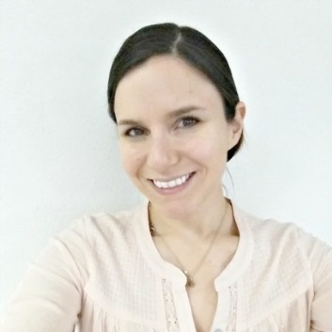 | Erin Grassie is a recruiter and student services advisor for Luna Community College in Las Vegas. In addition to her professional life, she is a fitness instructor and technology enthusiast with 15 years of experience.  When she is not promoting education, she is flying quad-copters and working on computers. She is also a member of PEO and runs a Twitch and YouTube channel in her spare time.
Lacy Houdek  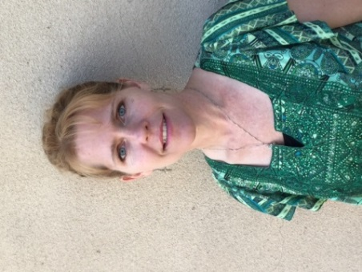 | Lacy Houdek is a Family Nurse Practitioner and the owner of Meadow City Family Clinic in Las Vegas. She is a graduate of the University of Texas, Luna Community College and the University of New Mexico. She has been privileged to travel and experience many different cultures and countries that have allowed her to appreciate and value others and her own country. She and her husband have three wonderful children.  Lacy believes that medicine is an art that is continually growing and changing. She looks forward to going to work every day and to learning something new as science and technology evolve our knowledge about diseases and widen our abilities to treat and manage them.
Carol Linder  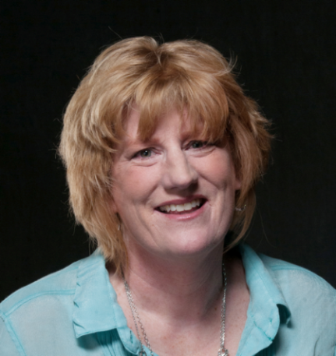 | Dr. Carol Linder grew up in Espanola, NM and graduated from UNM with a B.S. degree in exercise technology. She received her master’s in exercise physiology and PhD in cell and developmental biology from the University of Texas at Austin. She completed postdoctoral training in biochemistry at Washington State University. Dr. Linder worked at The Jackson Laboratory, a mouse genetics research institute in Bar Harbor, ME, where she helped other scientists use mice models in biomedical research.  She joined the Biology program at NM Highlands University in 2004. Her research in male reproduction focuses on understanding sperm development using mouse models of infertility. She has trained over 40 undergraduate students, 3 high school students, 13 graduate students, and one postdoctoral fellow. Five of her former students have gone on to complete PhDs. Dr. Linder has taught in the AAUW Girls’ Can program since its inception and loves introducing biomedical science to 5th graders.  Dr. Linder and her historian professor husband have two children, Katie (23) and Charlie (20). In her free time she enjoys Zumba, her women’s book club, singing in choirs, playing volleyball, walking her dogs Littlefish and Suitor, and traveling.
Mercy López  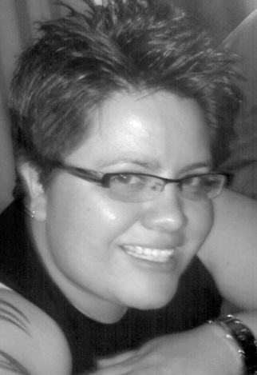 | Mercy López, a native of Pecos, New Mexico, graduated from Pecos High School and attended New Mexico Highlands University. While in college, she was the editor of the university’s student newspaper.  She is currently the features editor of the Las Vegas Optic. At the Optic she has received awards for photography, features, news reporting, columns, and investigative reporting from the New Mexico Press Association and the New Mexico Associated Press Managing Editors’ Better Newspaper Contest.  In 2011, the workaholic life that Lopez knew changed overnight. She became a single foster parent to a newborn baby girl, Mikayla, whom she officially adopted in 2013.  The group that she is most proud of serving in is Governor Susana Martinez’s Child Abuse Working Group. López worked alongside several state cabinet secretaries to identify loopholes in state laws and proposed various legislative bills to strengthen the child abuse and neglect laws.
Denette Martinez | Denette Martinez is a native New Mexican and an alumna of both New Mexico State University and New Mexico Highlands University. She graduated with a BA in Individualized Studies in Civil Engineering and Dance with a Minor in Nutrition at NMSU. At NMHU, she received a BA in Mathematics and completed a Secondary Education Licensure. She is currently finishing her MS in Computer Science from NMHU.  Martinez calls herself a renaissance woman in the 21st century. She enjoys art, dancing, and learning about different cultures. She has also been involved with helping students get involved in STEM programs. She has been involved with Project Guts and volunteers to judge student work in MESA. She teaches math and computers at Tierra Encantada Charter School in Santa Fe, NM.
Eliza Montoya  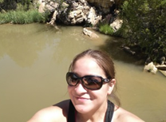 | Eliza Montoya started working with the Denver Zoo at Rio Mora National Wildlife Refuge in 2014 as the research and restoration intern. Eliza tracks weather station data, bison movement, and liaises with Denver-based work crews. She also supports land restoration projects, including building and prepping sites for erosion control and invasive weed control.  She grew up north of the Refuge in the small town of Springer (population: 994). In high school, Eliza joined the Rocky Mountain Youth Corp where she built a 1.5-mile long walking/running trail and a playground for the community of Cimarron. Eliza obtained her B.S. in Biology at New Mexico Highlands University. As an undergraduate, she interned for the U.S. Fish and Wildlife Service, where she measured groundwater well levels at Bosque del Apache National Wildlife Refuge.  In January 2015, Eliza started working towards her M.S. in Life Sciences, with a concentration in Biology, at NMHU. When she is not elbow deep in dirt, rocks and water, Eliza is an avid snowboarder and a doting mom to her precocious young daughter, Aubrey.
Debbie Pike  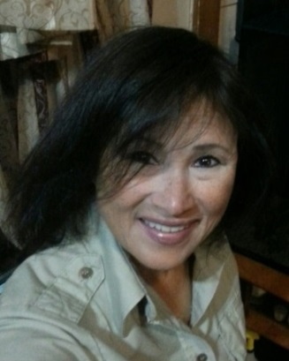 | Debbie Pike started her career with the U.S. Army. She traveled to Germany and when she returned to the United States she worked for Department of Defense for several years and then she began working for the Department of Interior. She is now the Visitors Services Manager for the Northern New Mexico National Wildlife Refuge, which is part of the United States Fish and Wildlife Service. Pike conducts public outreach and environmental education for Northern New Mexico.
Claudia Poglitsch  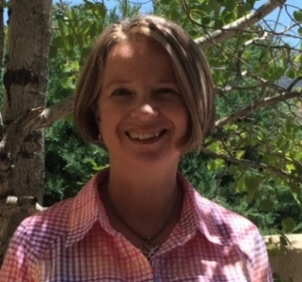 | Claudia Poglitsch is a retired biophysical and analytical research scientist who is currently reaching out to young people who may be interested in pursuing a career in STEM areas. She received a B.A. in chemistry from College of the Holy Cross and a Ph.D. in chemistry from the University of North Carolina at Chapel Hill where she developed new techniques in laser fluorescence microscopy to measure communication between proteins in our immune system that protect us from viruses and bacteria.  As a cancer research fellow at Stanford University Medical School she used electron microscopy to localize key parts of a very large protein machine found in each cell that transmits genetic information stored in DNA to RNA. At Caliper Technologies, a biotechnology company which pioneered new methods to miniaturize and automate chemical tests in a small glass chip which you can hold in your hand (microfluidics or “lab-on-a-chip”), she developed chemical tests used in discovering new drugs for treating diseases.
Shantini Ramakrishnan  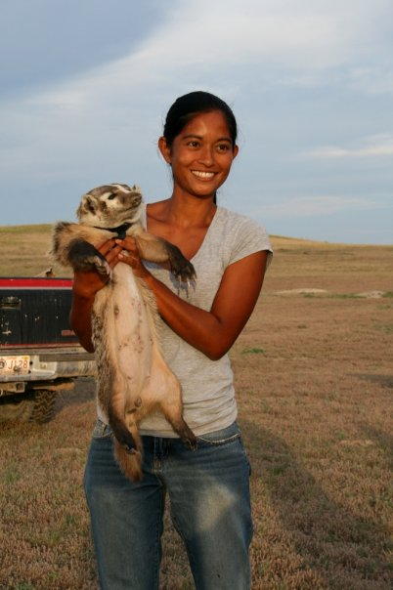 | Shantini Ramakrishnan moved to Wind River Ranch in May 2012 and joined the Denver Zoo team in September 2013 soon after the ranch became Rio Mora NWR. She started as the bison intern, coordinating field research trips to New Mexico for Denver-based staff and volunteers. Currently, she is the research and restoration coordinator where she develops and implements restoration projects in arroyos, grasslands and along the Mora River. She also engages student and adult volunteer groups in community outreach programs at the refuge.  This native of Malaysia is currently completing her M.S. in Life Sciences at NMHU. Her graduate research on plague ecology in small mammals was conducted at Rio Mora. She also holds a B.S. in Zoology and a B.A. in Mass Media.
Carla Romero  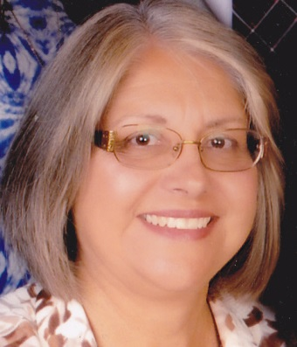 | 40 years ago, Carla Romero embarked on a career into one of the fastest changing and growing industries in the world - computer science. She graduated from New Mexico Highlands University majoring in mathematics. She worked at NMHU for 3 years programming in COBOL, FORTRAN, and PL/I using punched cards that were fed into the mainframe computer. In 1980, she was hired at Luna Community College to begin a Computer Information Systems program and purchase the first mainframe computer for the college.  She completed an MBA degree from NMHU December of 1984. She has taught classes in COBOL, FORTRAN, BASIC, JAVA, C++, and HTML as well as word processing and spreadsheet software such as WordPerfect, Word, LOTUS, EXCEL, dBASE, ACCESS, PowerPoint, PageMaker, and Publisher. Presently she teaches part-time in the NMHU School of Business and facilitates Project GUTS summer/afterschool computer modeling camps for middle school students.
Mary Schipper  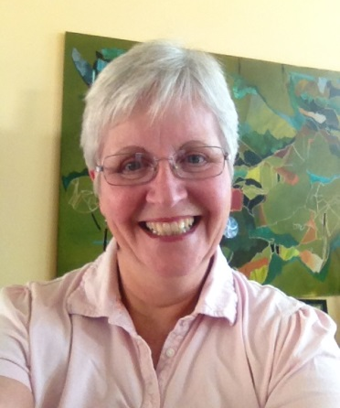 | Born in Ohio, as the oldest of four, Mary did her undergraduate studies at Ohio State University and then moved to Pennsylvania State University for medical school. Following three years of residency at Children's Hospital of Pittsburgh, she practiced general pediatrics in West Virginia, Maryland, Africa, and New Mexico. In 2011 she retired from Pediatrics after more than 30 years of practice. She is married, and the mother of two daughters. She and her husband, Tom, have resided in Las Vegas for more than ten years. During that time, she was the managing partner of the pediatric group practice in Las Vegas. She is active in her community as a Deacon in her church, a CASA volunteer, and a board member of the First Born of Northern New Mexico home visitation program in Las Vegas.
Mary Shaw  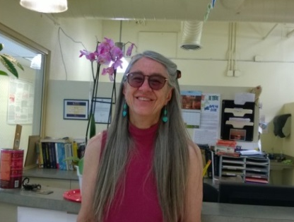 | Dr. Mary Shaw has a PhD in Plant Pathology from the University of California, Davis and has been teaching biology at NMHU since 1993. She has been teaching freshman biology for most of those years and is very interested in improving the way that biology is taught to help students learn to think as scientists. In her research she has moved away from plants and the bacteria that infect them. The research that she conducts uses bioinformatics tools to study fruit fly evolution and molecular biology with students. Mary lives on a ranch with her horse, angora goats, dogs and cats.
Nina Thayer  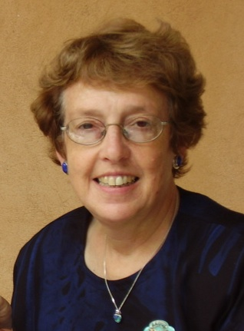 | Nina was born and raised in Ohio and has lived the past 37 years in New Mexico. She graduated with degrees in physics from Earlham College and the U. of Maryland. Her career included many government-funded projects ranging from processing digital images of Mercury and Venus from the Mariner X mission in 1974, to identifying genes on viral, bacterial and human DNA sequences (1999-retirement).  Over her 42 years in AAUW Nina has held numerous branch, state and national positions including AAUW-NM co-president (2006-10), serving with her friend and fellow scientist, Nancy Scheer. Nina currently serves on the national AAUW Branch Program Resources Committee and her local Los Alamos Branch Council. She enjoys activities with her husband, Gary, two children and four grandchildren as well as hiking, skiing, reading and stitching.
Laurie Waters  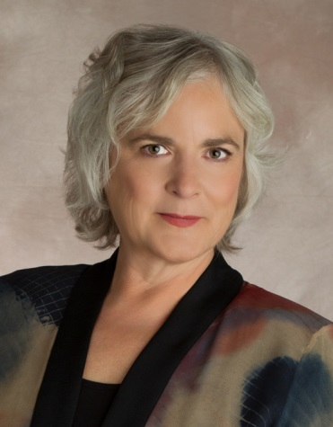 | Laurie Waters is a PhD Nuclear Physicist who worked at Los Alamos National Laboratory from 1991 to 2012, and since then has done contract work with the TechSource company for organizations like the Department of Homeland Security. She specializes in radiation transport computer simulations, and was a key player in the development of the MCNPX code.  She has also done experimental research in high-energy and relativistic heavy-ion physics, but primarily specializes in intermediate energy spallation physics. This involves designing accelerator targets to produce neutrons and other particles for threat reduction applications, as well as medical isotopes for industry.
Helena Whyte  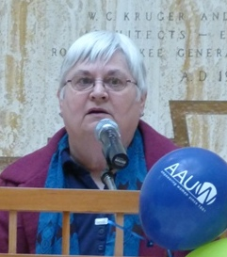 | Helena Whyte was born in Albuquerque, NM. She received a B.S. in chemistry at New Mexico Tech and an M.A. in science education at University of New Mexico. She began and ended her career as a High School Science teacher. She is a retired staff member from Los Alamos National Laboratory where she designed and implemented chemical inventory and hazardous material exposure databases. She was a safety analyst, author of safety training courses, and producer of award winning safety training videos. She is a published author of peer-reviewed journal articles and book chapters.  As a safety analyst, she investigated and examined the workplace for hazards and potential dangers, made recommendations on improving the safety of workers and the surrounding community, and conducted scientific research to provide data on possible harmful conditions in the workplace.
Kate Zeigler  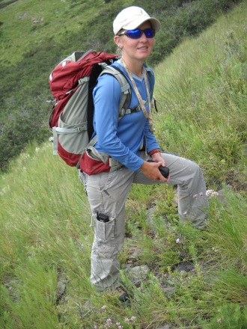 | Dr. Kate Zeigler is owner of Zeigler Geologic Consulting, LLC, a woman-owned company in Albuquerque which has worked on projects that include paleontologic resource management, groundwater hydrogeology, geological mapping, geoarchaeology, conservation easement assessments and well log analyses. She also continues to pursue other research interests, including field-oriented studies in magnetostratigraphy, lithostratigraphy, vertebrate paleontology and biostratigraphy.  Dr. Zeigler was granted her B.A. from Rice University in Geology and Anthropology. She obtained her M.S. and Ph.D. from the University of New Mexico in 2002 and 2008 respectively. Dr. Zeigler served on the Executive Committee of the New Mexico Geological Society (2006-2011) and is the current Chair of the Scholarship Program. She chairs the Rocky Mountain Section of the Geological Society of America. In addition, she coaches a local high school Science Olympiad team and is engaged in several programs for mentoring girls in STEM disciplines.

