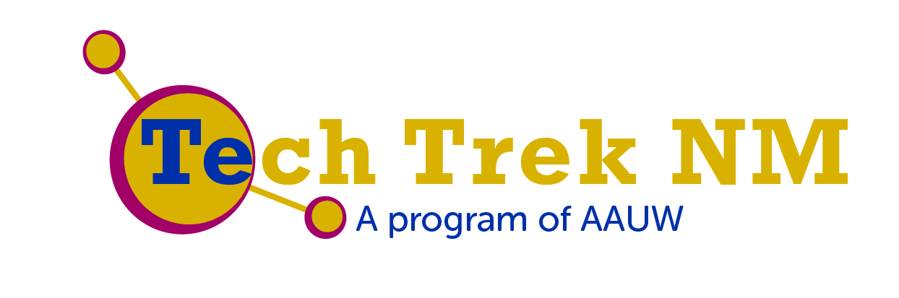

July 12 - 18, 2015

New Mexico Highlands University

Las Vegas, New Mexico

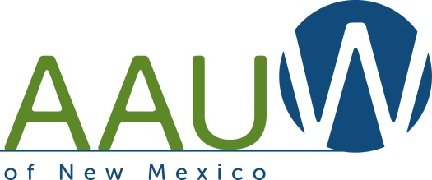

Our mission: Advancing equity for women and girls through advocacy, education, philanthropy, and research.

The American Association of University Women (AAUW) is the nation’s leading voice promoting equity and education for women and girls. Since our founding in 1881, AAUW members have examined and taken positions on the fundamental issues of the day — educational, social, economic, and political.

Tech Trek 2015 Steering Committee

Director | Elizabeth Ratzlaff | Las Vegas
Assistant Director | Karyl Lyne | Las Vegas
Fundraising Coordinator | Mary Rita Chapman | Las Cruces
Family & Student Involvement Coordinator | Cheri Burch | Albuquerque
Social Media Coordinator | Helena Whyte | Los Alamos
Marketing Coordinator | Jan Bandrofchak | Albuquerque
Volunteer Coordinator | Mary Schipper | Las Vegas

To learn more about AAUW’s groundbreaking studies: Solving the Equation: The Variables for Women’s Success in Engineering and Computing and Why So Few? Women in Science, Technology, Engineering, and Mathematics?, visit the AAUW website: www.aauw.org/learn/research/whysofew.cfm
http://www.aauw.org/research/solving-the-equation/

You can reach AAUW-NM at:
http://aauw-nm.aauw.net/
Facebook: https://www.facebook.com/aauw.new.mexico
Twitter: https://twitter.com/aauwnm
Tech Trek Core Classes

Computer Modeling and Simulations of Chemical Reactions: Learn the basic concepts in modeling complex systems using StarLogo Nova, a modeling and simulation environment developed at MIT.
Instructor: Dr. Lina Germann

From Sun to Us: Explore the types of solar energy and its uses through building a solar-powered battery charger, solar still and solar cooker. Instructors: Athena Christodolou and Angela Arriaga

App Inventors: Learn basic computer science concepts through an introduction to designing and developing apps using the software MIT App Inventor 2. Instructors: Denette Martinez and Erin Gilland

The Biomechanics of the Heart: Investigate the heart as a pump, consider how valves and pumps work to move blood and investigate the implications of blood pressure through the development of a model of the human heart and circulatory system.
Instructor: Donna Ortiz

AAUW-NM is very grateful to the faculty, staff and administration of New Mexico Highlands University for their generous and enthusiastic support of Tech Trek NM 2015. We are especially indebted to Camp Director Elizabeth Ratzlaff for her wonderful leadership, thoughtful planning, clear thinking, amazing organizational skills, recruiting efforts and enthusiastic advocacy of STEM education for all young people. Thank you, Elizabeth.

Tech Trek 2015 Workshops and Instructors
Baking with the Sun | Athena Christodolou and Angela Arriaga
Design with Engineering in Mind | Julie Walleisa
DNA Extraction | Dr. Mary Shaw
Drone On and On | Erin Grassie
Faces of Cancer | Dr. Carol Linder
Friends Forever | Corilia Ortega
Getting to know Frogs- Inside and out! | Helen Bolen
Growth Mindsets | Dr. Carol Linder and Elizabeth Ratzlaff
Light, Color and Sparkles | Dr. Laurie Waters
Lighten Up: Using Light in Designs | Alice Shriver and Janette Frigo
Mapping with Pixels | Amanda Aragon
One Hour of Code | Dr. Josephine Killdee
Physiologically Speaking | Jessica Snow
Probably So! Probability and Statistics | Cheri Burch
River Assessment | Lea Knutson and Lorraine Garcia
The Internet and You- How to Stay Safe and Post Smartly | Erin Grassie
The Water Beneath Our Feet | Dr. Kate Zeigler
We Are What We Eat | Dr. Carol Linder
Wildfire Science- It's Hot! | Dr. Sara Brown

Volunteers and Camp Staff
Camp Director: Elizabeth Ratzlaff
Assistant Director: Dr. Karyl Lyne
Health Aide: Dr. Mary Schipper
Core Class and Workshop Hosts: Sonya Berg, Meredith Britt, Cheri Burch, Jill Foreman, Louise Gerstle, Lynn Heffron, Martha McCaffrey, Phyllis Ludi, Dr. Claudia Poglitsch, Donna Rivas, Jean Sorrell-Jones, Nina Thayer, Dr. Carol Winkel
Camp Photographer: Monique Esquibel
Dorm Monitors: Cheri Burch, Corilia Ortega, Dr. Claudia Poglitsch,
Helena Whyte
Student Counselors: Helene Beauchamp, Laurel Carr, Lorraine Garcia, Rachael Lucero, Danielle Martin, Kushum Shrestha, Rosie Vasquez
General: Lynn Gates, Dolores Lopez, Dorothy Maestas,
Donna Rivas
Campers
School
Albuquerque
Makayla Marquez Tierra Adentro
Allison Covington Cleveland Middle School
Kendra Giersch Montessori Middle School
Zora Lehmer-Mearns Montessori Middle School
BreOnna Lucero Wilson Middle School
Roxanne Marquez Mission Achievement School
Vivien McCullough Cleveland Middle School
Amanda Perea Public Academy for Performing Arts
Sierra Romero Montessori Middle School
Kayla Weber Our Lady of Annunciation
Zhane Gomez-Bravo Public Academy for Performing Arts
Leticia Lopez Van Buren Middle School

Belen
Kaeley Chavez St. Mary's Catholic School

Bosque Farms
Reyna Mayer Torres Valencia Middle School

Carlsbad
Madelynn Boam Carlsbad Intermediate School
Kylie Pinzel Carlsbad Intermediate School
Rachel Rogers Carlsbad Intermediate School

Corrales
Emily Swinson Our Lady of Annunciation
Eva Wilson Cien Aguas International School

Las Cruces
Vivian Allen La Academia Dolores Huerta Middle School
Athena Angel Lynn Middle School
Katy Boetticher-Northcutt Lynn Middle School
Liah Rebeca Guerrero Mesa Middle School
Galilea Gutierrez La Academia Dolores Huerta Middle School
Ariya Nilkaew Vista Middle School
Carmen Sanchez La Academia Dolores Huerta Middle School

Los Alamos
Sarah Crotzer Los Alamos Middle School
Malea Joyce Los Alamos Middle School

Los Lunas
Marisa Armijo Los Lunas Middle School
Zoe Bennett La Plata Middle School
Olivia Caven Los Lunas Middle School
Kitra Noce Cleveland Middle School

Mesilla
Rigel Liefeld Home School

Moriarty
Maria Ford Estancia Valley Classical Academy
Autumn Shelton Estancia Valley Classical Academy

Peralta
Makayla Gates Valencia Middle School

Rio Rancho
Amisha Choudhary Mountain View Middle School
Peyton Elder Mountain View Middle School
Jordan Moody Eagle Ridge Middle School

Sandia Park
Maisy Dunlavy Roosevelt Middle School

Santa Fe
Fiona Ellis-Green Santa Fe Girls School
Gabriella Gabaldon Tierra Encantada Santa Fe
Alexa Maes Aspen Community Magnet School
Sofia Ortiz Santa Fe Girl's School
Etta Pope Academy of Technology and the Classics

Silver City
Miriam Frisch Aldo Leopold Charter School
Theresa Gutierrez La Plata Middle School

Socorro
Aolani Avalos Sarracino Middle School
$1,000 to $2,500
Many Thanks to our Donors!
Anonymous
AAUW-New Mexico
AAUW-Las Cruces
Sylvia Fink
Walmart, Las Vegas

$500 to $499
AAUW-Las Vegas
AAUW-Santa Fe
Cheri Burch
Sharon Diamond
Marilyn Doolen
El Paso Electric
First United Presbyterian Church, Las Vegas
Elizabeth Gordon
Karyl Lyne
Judyth Prono

$250 to $499
Anonymous
AAUW-Los Alamos
Gerald Bloomer
Mary Rita Chapman
Kosh Solutions, Las Cruces
Rosemarie Montoya, State Farm Insurance, Las Vegas
Sunrise Kiwanis, Las Vegas
Nina Thayer

$100 to $249
Jan Bandrofchak
Ruth Benjamins
Billingsley Engineering, Las Vegas

BTU Building Materials, Las Vegas
Helaine Burstein
Kathleen Cordova, DDS
Pamela Daves
Joy Donelson
Jowilla Forman
Patricia Freeman
Gwedolyn Hanson
Marsha Hokkanen
Carolyn Jo Kaye
Linda King
Laurine LaPlanche
Gregg Lapore
Patricia Maben
Ann McCullough
Phoebe Pierce
Elizabeth Ratzlaff
Ieva Rasmussen
Donna Rea
Jo Marie Rose
Nancy Scheer
Jane Sherwood
Katrin Sumpter

Up to $99
Shirley Abbott
Shirley Ash
Nancy Baker
Jan Bray
Mary Browne
Mary Campbell
Ann Carden
Susan Cho
Ann Clewlow

Cristine Cloyd
Helen Disque
Harriet Dodder
Marilyn Dunn
Bonnie Eisenberg
Denise George
Louise Gerstle
Judy Kares
Gina Lubeck
Natalie Markin
Judith Minks
Marilyn Minshall
Lynn Mulholland
Carol Neal
Ann Palormo
Jeanne Patrick
Shirley Patterson
Frances Plec
Karin Roberts
Shelley Rossbach
Bonnie Rutherford
Bonnie Schranz
Betty Smith
Pamela Sharp
Marilyn Thayer
Carroll Thomas
Alahna Weller
Virginia White
Helen Whitesides
Helena Whyte
Mary Ann Willson
Carol Woodworth
Rozelle Wright

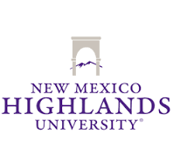
Sponsored by:
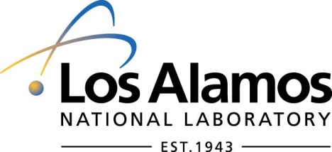
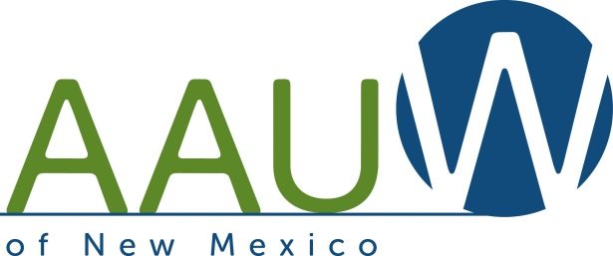
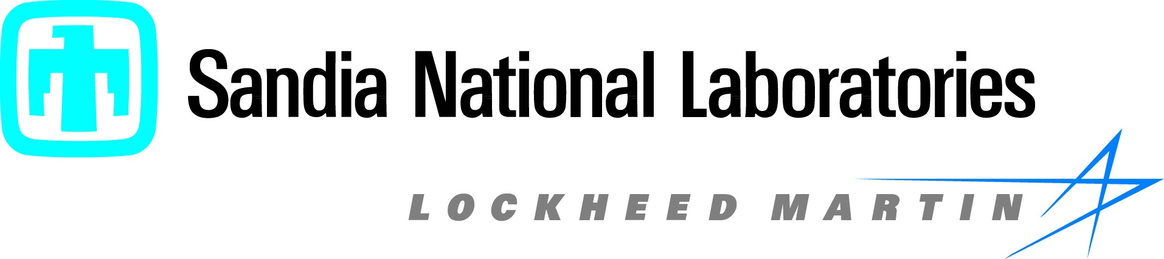

2015 AAUW Tech Trek National Sponsors:
